Defect ID | : CMS_CardReissue_0024
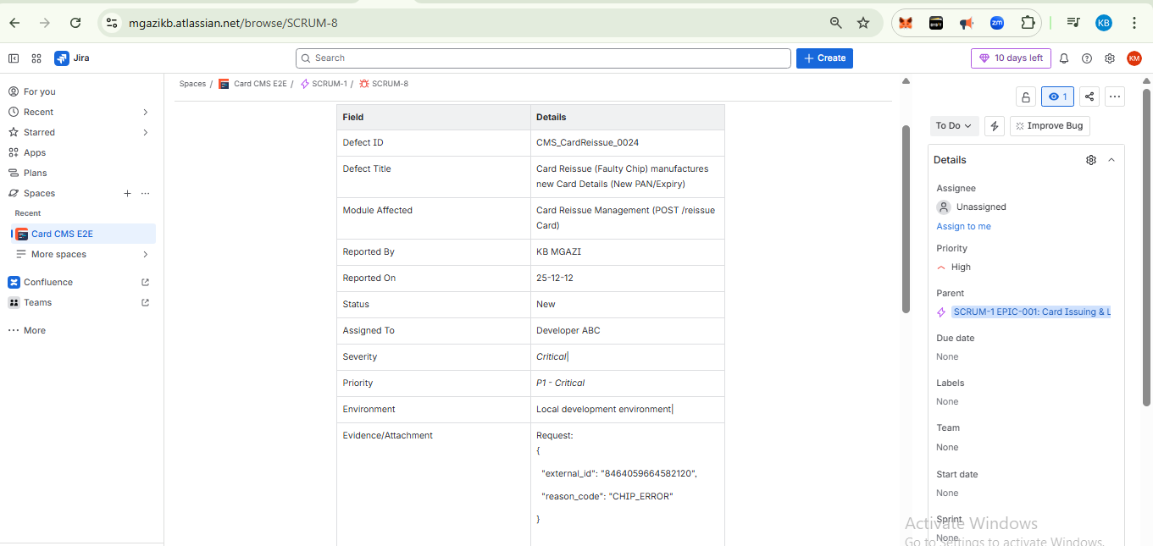
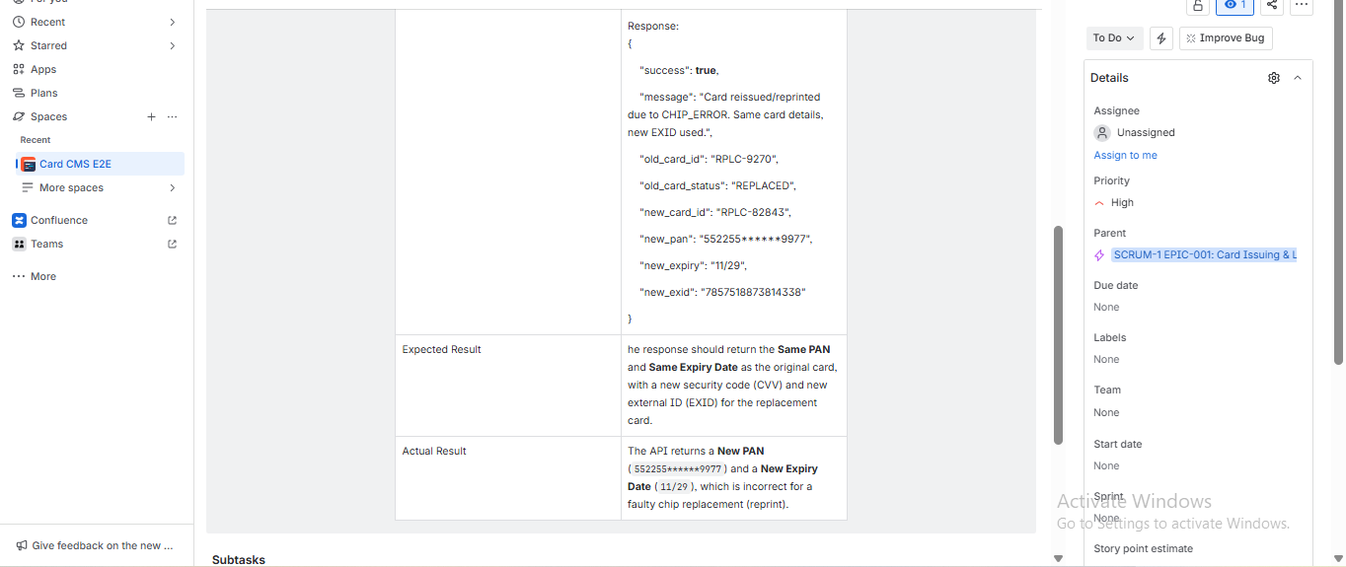

Defect ID : CMS_CardReissue_0024
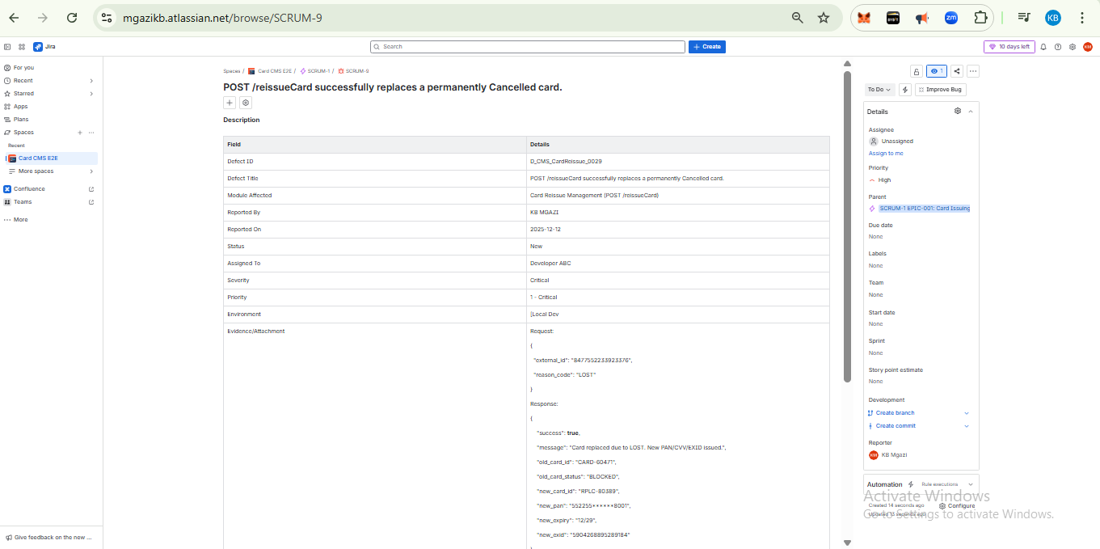
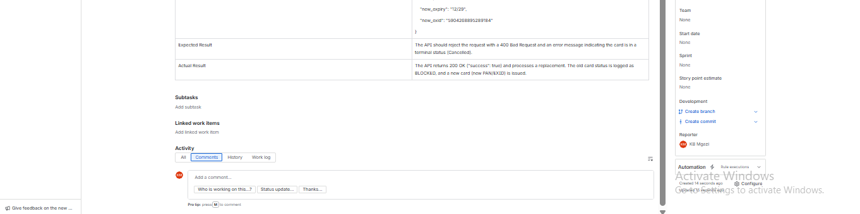
Test Plan :
https://mgazikb.atlassian.net/wiki/spaces/~712020ad3a4725952b4d4f899c9d487f9ce588/pages/262162/Card+Issuing+Lifecycle+Test+Plan?atlOrigin=eyJpIjoiYzA2Mjc3YmM4NWNiNDFjYWJlY2U4MzRkZmQyMmRjOTAiLCJwIjoiYyJ9
Test Summary Report:
https://mgazikb.atlassian.net/wiki/spaces/~712020ad3a4725952b4d4f899c9d487f9ce588/pages/6553602/Test+Summary+Report+TSR+-+Card+Management+System?atlOrigin=eyJpIjoiZWY0NDhmMWU5YThiNDMwYzlhMzg2NTM5OGU3MDgwZjQiLCJwIjoiYyJ9

